SIR APOLLO KAGGWA SCHOOLS
MID TERM II - 2024
PRIMARY SIX
INTEGRATED SCIENCE
Time allowed: 2 hours 15 minutes

Name: ______________________________________________________________
School: _____________________________________________________________
FOR EXAMINER’S USE ONLY
Read the following instructions carefully:
- The paper has two sections: A and B
- Section A has 40 questions (40 marks)
FOR EXAMINER’S USE ONLY

Qn. No | MARK | SIGN
1 – 10
11 – 20
21 – 30
31 – 40
41 – 43
44 – 46
47 – 49
50 – 52
53 – 55
TOTAL

- Section B has 15 questions (60 marks)
- Answer ALL questions. All answers to both Sections A
and B must be written in the spaces provided.
- All answers must be written using a blue or black ball
point pen or ink. Diagrams should be drawn in pencil.
- Unnecessary crossing of work may lead to loss of marks.
- Any handwriting that cannot be easily read may lead to
loss of marks.
- Do not fill anything in the boxes indicated;
For Examiner’s use only.

Turn over

SECTION A
1. Name the part of the ear that maintains body posture.
_____________________________________________________________________
2. What is the major role of leaves on plants?
_____________________________________________________________________
_____________________________________________________________________
3. Give one use of antennae to an insect.
_____________________________________________________________________
_____________________________________________________________________
4. How does heat travel in a vacuum?
_____________________________________________________________________
_____________________________________________________________________
5. Why does a millet farmer need sunshine?
_____________________________________________________________________
_____________________________________________________________________
6. In what state of matter is water vapour?
_____________________________________________________________________
_____________________________________________________________________
7. Which element of PHC caters for casualties?
_____________________________________________________________________
_____________________________________________________________________
8. What is the gestation period of a sow?
_____________________________________________________________________
_____________________________________________________________________
9. How can a family protect children from nutritional deficiency diseases?
_____________________________________________________________________
_____________________________________________________________________
10. Calculate the mass of an object whose volume is 15cc and density of 2g/cc

11. Why is it good to chew food properly before swallowing it?
_____________________________________________________________________
_____________________________________________________________________
12. Name one example of birds with such a beak.
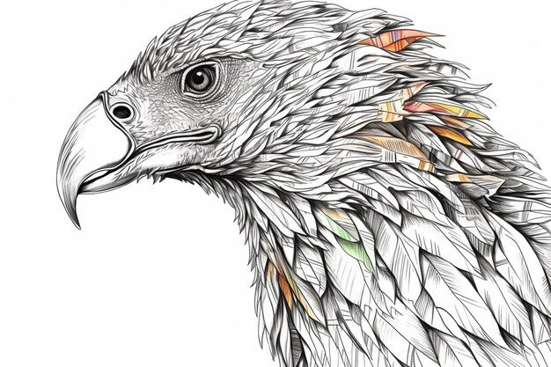

_____________________________________________________________________
13. Explain why farmers are encouraged to plant leguminous crops during crop rotation.
_____________________________________________________________________
_____________________________________________________________________
14. Which part of air is needed for burning to take place?
_____________________________________________________________________
15. Suggest one excuse people in your village give for drinking alcohol.
_____________________________________________________________________
_____________________________________________________________________
16. Name one exotic breed of goats kept for milk production.
_____________________________________________________________________
17. What do you understand by the term “germination”?
_____________________________________________________________________
_____________________________________________________________________
18. What eye disease do the Chlamydia germs spread?
_____________________________________________________________________
19. Apart from weaning babies, give one other example of vulnerable people.
_____________________________________________________________________
20. Why is the government of Uganda seriously giving its people free mosquito nets through VHT’s?
_____________________________________________________________________
_____________________________________________________________________
21. By what process is food broken down into simple soluble substances which can be absorbed into the body?
_____________________________________________________________________
_____________________________________________________________________
22. Why is melting of ice to water considered as a physical change?
_____________________________________________________________________
_____________________________________________________________________
23. Give a reason why roughages should be included in our diet.
____________________________________________________________________
_____________________________________________________________________
24. Name the type of soil used for modelling.
_____________________________________________________________________
25. Why does a piece of paper float on water?
_____________________________________________________________________
_____________________________________________________________________
26. Give a reason why farmers debeak their birds.
_____________________________________________________________________
_____________________________________________________________________
27. Give one role of the worker bee in a hive.
_____________________________________________________________________
_____________________________________________________________________
28. Why do earthworms come out of the ground immediately after it has rained?
_____________________________________________________________________
_____________________________________________________________________
29. A girl held a piece of metal at point P. after some time, she felt some heat at P. By what process did heat reach point P?
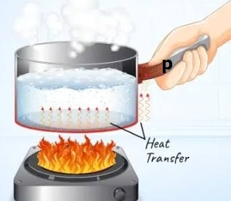

_____________________________________________________________________
_____________________________________________________________________
30. Give one example of an egg laying mammal.
_____________________________________________________________________
31. How does yeast reproduce?
_____________________________________________________________________
32. Give the importance of blood plasma in the body.
_____________________________________________________________________
_____________________________________________________________________
33. How does a turtle protect itself?
_____________________________________________________________________
_____________________________________________________________________
34. Suggest one advantage of mulching.
_____________________________________________________________________
_____________________________________________________________________
35. Suggest one importance of transpiration to plants.
_____________________________________________________________________
_____________________________________________________________________
36. What is immunity?
_____________________________________________________________________
_____________________________________________________________________
37. Name any one dangerous chemical found in tobacco.
_____________________________________________________________________
38. Write one characteristic of essential drugs.
_____________________________________________________________________
_____________________________________________________________________
39. Why do objects thrown in air come back on the ground.
_____________________________________________________________________
_____________________________________________________________________
40. Give the importance of the garden tool shown below.
_____________________________________________________________________

SECTION B
(Questions in this section carry 4 marks each)
41. (a) What is First Aid?
________________________________________________________________
________________________________________________________________
(b) Give two qualities of a good First Aider.
(i) ________________________________________________________________
________________________________________________________________
(ii) ________________________________________________________________
________________________________________________________________
(c) Who is a casualty?
________________________________________________________________
________________________________________________________________
42. Study the animals given in list A and those in list B and use them to answer questions that follow
A B
fish man
bird whale
frog bat
(a) To what class of vertebrates do animals in list B belong?
________________________________________________________________
(b) How are animals in list A similar in terms of reproduction?
________________________________________________________________
________________________________________________________________
(c) Give one similarity between animals in list A and list B.
________________________________________________________________
________________________________________________________________
(d) How is a toad different from a fish in the way they breathe?
________________________________________________________________
________________________________________________________________

43. (a) What are weeds?
________________________________________________________________
________________________________________________________________
(b) Give any two disadvantages of weeds in a garden.
(i) ________________________________________________________________
_______________________________________________________________
ii) ________________________________________________________________
________________________________________________________________
- Write down one way of controlling weeds in the garden.
________________________________________________________________
________________________________________________________________
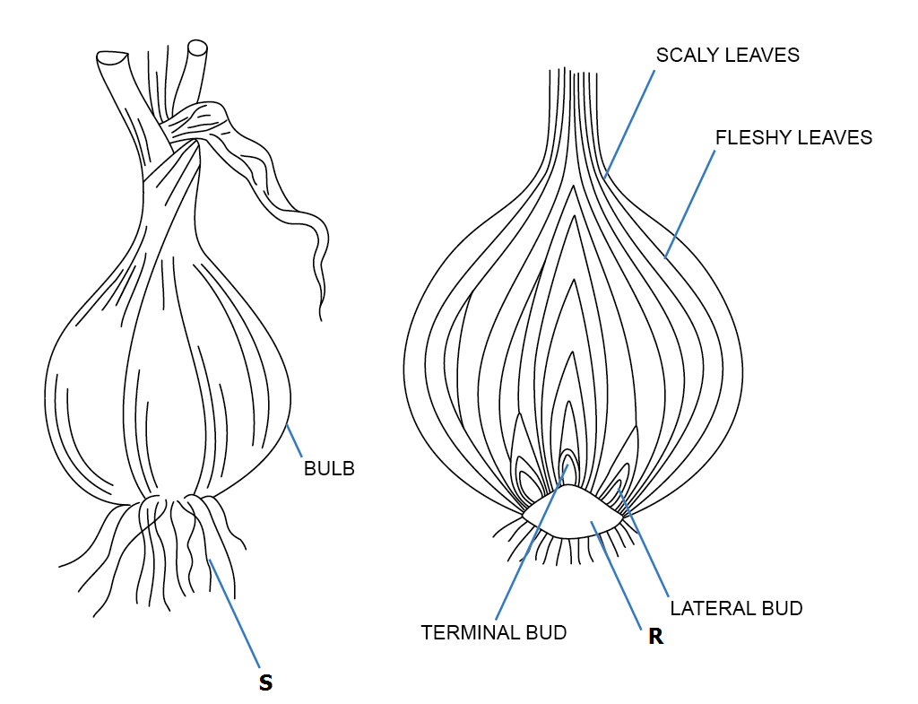
44. The diagram below shows a cross section of an onion.

(a) Name the parts marked;
(i) R ___________________________________________________________
(ii) S ___________________________________________________________
(b) State the function of part R to the plant.
________________________________________________________________
________________________________________________________________
(c) How is the above plant propagated?
________________________________________________________________
________________________________________________________________
45. (a) What is temperature?
________________________________________________________________
________________________________________________________________
(b) What is the normal body temperature of a person?
_______________________________________________________________
(c) Change 40⁰C to Fahrenheit scale. (2 marks)

46. Match the diseases to their crops correctly.
(i) Panama tomatoes
(ii) Tomato blight cassava
(iii) Cassava mosaic ground nuts
(iv) Rosette bananas
(i) Panama ____________________________________________________
(ii) Tomato blight __________________________________________________
(iii) Cassava mosaic ________________________________________________
(iv) Rosette _______________________________________________________
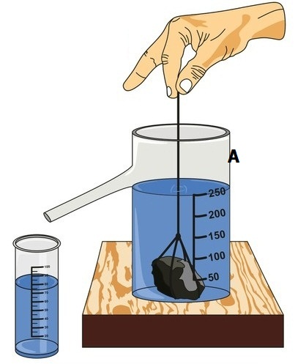
47. Study the diagram below and answer the questions that follow.

(a) Name the method of finding volume shown.
_______________________________________________________________
________________________________________________________________
(b) Why is this method used to find the volume of the stone?
________________________________________________________________
_______________________________________________________________
(c) Name the apparatus labelled A.
_______________________________________________________________
________________________________________________________________
48. (a) Give two common characteristics between reptiles and birds.
(i) ________________________________________________________________
________________________________________________________________
(ii) ________________________________________________________________
________________________________________________________________
(b) How do the following protect themselves?
(i) Tortoise
________________________________________________________________
________________________________________________________________
(ii) Millipede
________________________________________________________________
________________________________________________________________
49. (a) What is an accident?
________________________________________________________________
________________________________________________________________
(b) Write down any one cause of road accidents.
________________________________________________________________
________________________________________________________________
(c) State any two reasons for giving First Aid.
(i) ________________________________________________________________
________________________________________________________________
(ii) ________________________________________________________________
________________________________________________________________

50 Use the table below to answer questions that follow.
List A | List B | List C | List D
Kite | Monkey | Tortoise | Housefly
Ostrich | Rat | Snake | Cockroach
Vulture | Man | Lizard | Rickets
Hen | Kangaroo | Gecko | Moths

(a) How is the gecko in group C able to walk upside down on the ceiling?
________________________________________________________________
________________________________________________________________
(b) What type of fertilization do animals in list B undergo?
________________________________________________________________
________________________________________________________________
(c) Why are animals in list C said to be cold blooded?
________________________________________________________________
________________________________________________________________
(d) To which group of vertebrates do animals in list A belong?
________________________________________________________________
________________________________________________________________
51. (a) Explain the following terms briefly.
(i) Active smoking
________________________________________________________________
________________________________________________________________
(ii) Passive smoking
________________________________________________________________
________________________________________________________________
(b) Which body organ is greatly damaged by smoking?
________________________________________________________________
(c) State the name given to one of the chemical substances found in tobacco.
________________________________________________________________
52. (a) State one role of a health prefect in your school.
________________________________________________________________
________________________________________________________________
(b) Identify one activity done during a health parade.
________________________________________________________________
________________________________________________________________
(c) Give one reason why school children bathe regularly.
________________________________________________________________
________________________________________________________________
(d) Why do we use soap when washing clothes?
________________________________________________________________
________________________________________________________________

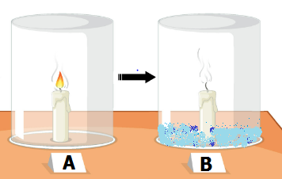
53. The diagram below shows two stages in an experiment . Use it to answer questions that follow.

(a) Why did the candle flame continue burning in jar A?
________________________________________________________________
________________________________________________________________
(b) Why did the candle flame go out in jar B?
________________________________________________________________
________________________________________________________________
(c) Apart from burning, identify any other process that needs oxygen to occur.
________________________________________________________________
_______________________________________________________________
(d) Give a reason for the rise in the water level as shown in jar B above.
________________________________________________________________
________________________________________________________________

54. (a) Write STIs in full.
________________________________________________________________
________________________________________________________________
(b) Mention one example of STIs.
________________________________________________________________
(c) Why are STIs said to be communicable diseases?
________________________________________________________________
________________________________________________________________
(d) Which STI causes blindness in babies?
________________________________________________________________
55. Match the blood vessels in list A to their functions in list B.
A B
(i) Veins - carry oxygenated blood from the heart to all body parts.
(ii) Arteries - carry blood away from the heart.
(iii) Pulmonary artery - carry blood towards the heart.
(iv) Pulmonary vein - carry de-oxygenated blood from the heart to the lungs.
- Veins ___________________________________________________________
- Arteries _________________________________________________________
- Pulmonary artery _________________________________________________
- Pulmonary vein ___________________________________________________

Good luck

P.6 Science 2024
- Semi-circular canal
- To manufacture starch
- Feeling/Sensing danger/temperature changes/communication
- By means of radiation
- To be able to dry the harvested millet.
- Gas/Gaseous state
- First Aid
- 3 months 3 weeks 3 days
- By providing a balanced diet regularly.
- Mass= density x volume
= 2g/cc x 15cc
= 30g
- For easy swallowing/It eases digestion/It reduces risks of foreign bodies in the throat.
- Eagle/Kite/Secretary bird/Owl/Hawk/ Vultures/ Crow
- In order to fix nitrogen into the soil/To improve soil fertility.
- Oxygen
- Boredom/to relax and pass time/To socialize with colleagues/to forget their problems/To fit among their peers/To celebrate achievements.
- Toggenburg/saanen
- Germination is the process by which a seed develops into a seedling.
- Trachoma
- Expectant mothers/Breast feeding mothers/The sick/convalescents/The elderly/Invalids
- To reduce cases of malaria/To reduce mortality due to malaria/To guard people against mosquito bites and malaria.
- Digestion
- No new substance is formed in melting of ice to water.
- To prevent constipation/They allow easy digestion of food.
- …because a piece of paper is less dense than water.
- Clay soil
- To prevent cannibalism.
- It protects the hive/Defends the hive/Builds the honey comb/Collects nectar for honey/Repairing the hive.
- To get more oxygen
- By means of conduction.
- Duck-billed platypus
- By means of cell budding
- To transport digested food antibodies, homonies etc
- By withdrawing its tail, head and legs into its hard shell.
- Mulching is cheap/mulches are easily accessed/Mulches are affordable.
- Transpiration helps a plant to cool down during hot weather.
- The ability of the body to resist/fight germs that enter the body.
- Tar/Nicotine
- They are properly packed/They are available/They have clear dosage/They have a clear lifespan.
- Due to gravitational force/pull.
- Cutting down cereals/Cutting tall grass.
- –
- First Aid is the first help/immediate help given to a casualty before being taken to the hospital.
- Kind/sympathetic/quick/empathetic
- A person who has got an accident
- –
- Mammals
- They all lay eggs as a way of reproduction.
- All animals in lists A and B are vertebrates.
- A toad breathes through lungs and moist skin whereas a fish uses gills to breath.
- –
- Weeds are the unwanted plants in a garden.
- Weeds compete for nutrients with the wanted crops which leads to poor yields/ Weeds act as home for pests.
- Mulching/spraying herbicides/digging out the weeds/uprooting the weeds and burying them.
- –
- R – stem S – adventitious roots/ roots
- ...........................................
- By using bulbs/By means of seeds.
- –
- Temperature is the degree of hotness or coldness of matter.
- 37⁰C (98.6⁰F)
- ⁰F = 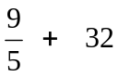
= 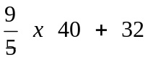
= 72 + 32
= 104⁰F
- –
- Bananas
- Tomatoes
- Cassava
- Ground nuts
- –
- Displacement method
- The stone is an irregular object
- Measuring cylinder
- –
- Both reptiles and birds lay eggs/Have scales/Both undergo internal fertilization/ Both reptiles and birds are vertebrates.
- (i) Withdrawing legs and head into its hard shell.
(ii) By coiling up/curling
- –
- An accident is a sudden happening that causes harm to the body.
- Overloading vehicles/Using vehicles in dangerous mechanical condition/Over speeding/Driving under the influence of alcohol.
- To save life/To stop bleeding/To reduce pain.
- –
- The gecko uses its suction pads.
- Internal fertilization.
- …because their body temperature changes according to that of the surrounding environment.
- They belong to birds.
- –
- (i) Active smoking is the inhaling of tobacco smoke directly from a pipe or cigarette.
(ii) The inhaling of tobacco smoke that is exhaled by an active smoke.
- The lungs
- Tar/Nicotin
- –
- A health prefect organizes health parades.
- Checking the level of personal hygiene among children.
- To prevent bad smell.
- The chemicals in the soap make it easy to remove dirt/So that we can kill the germs in the clothes.
- –
- ….because there was oxygen in jar A.
- …because oxygen was used up in jar B.
- Germination/rusting
- Water in jar B rose to occupy the space left by the used up air.
- –
- Sexually Transmitted Infection.
- HIV/AIDS/Gonorrhea/Syphilis/Candida/ etc
- ..because STIs are spread from one infected person to a healthy person.
- Syphilis
- –
- Veins – carry blood towards the heart.
- Arteries – carry blood away from the heart.
- Pulmonary artery – carry de-oxygenated blood from the heart to the lungs.
- Pulmonary vein – carry oxygenated blood from the heart to all body parts.

